D.K.T.E. Society’s Textile and Engineering Institute, Ichalkaranji.
(An Empowered Autonomous Institute, Affiliated to Shivaji University, Kolhapur)
Department of Computer Science And Engineering(AI) 2025-2026


Project Synopsis On
The Tech-Integrated Charity Chain for Transparent Giving and Efficient Aid Delivery

Under The Guidance Of
Prof. S. D. Rane
Submitted By:

PRN Name

22UAI054 Vinay S. Khapare

22UAI059 Pranav D. Khot

22UAI041 Jaydeep A. Patil

22UAI043 Arkaj U. Kadam

22UAI004 Shreyash P. Alase

Prof. S. D. Rane Prof. Dr. S. K. Shirgave
Project Guide Head Of Department

INDEX

Sr.  No. | Title | Page No.
1. | Introduction | 3
2. | Overall Description | 4
3. | Specific Requirements | 7
4. | Software Design  Document | 10
5. | Code and Outputs | 18
6. | References | 25

- Introduction
- Purpose
The purpose of this Software Requirements Specification (SRS) document is to define and describe the complete functionality, features, and design constraints of the system titled “The Tech-Integrated Charity Chain for Transparent Giving and Efficient Aid Delivery.”
The aim of this system is to build a transparent and technology-driven platform where donors, NGOs, and beneficiaries are connected through a secure and verifiable digital chain. This SRS will guide developers, testers, and evaluators through the system’s lifecycle, ensuring that all functionalities align with the project’s objectives — transparency, accountability, and efficiency in charitable transactions.
- Scope

The Tech-Integrated Charity Chain provides a digital platform that allows donors to contribute funds or resources to verified charities and track how those donations are used.
The system integrates blockchain-inspired transparency, smart analytics, and real-time dashboards to ensure every donation is visible, traceable, and efficiently allocated.

Key stakeholders include:
  - Donors (individuals or organizations)
  - NGOs and charitable institutions
  - Administrators managing transactions and user verification
  - Beneficiaries receiving aid

Main features include:
  - User registration and authentication
  - Verified NGO listing and donation campaigns
  - Secure online donations (monetary or material)
  - Real-time transaction tracking and history
  - Transparent record management through MongoDB
  - Report generation and donor impact visualization

- Overall Description

This section provides an overview of the system’s components, operational environment, and architecture.

Product Perspective
The system functions as a web-based application developed using React for the frontend and Node.js with Express for the backend. MongoDB serves as the database for storing user, transaction, and campaign data.
The architecture follows a client-server model, ensuring modularity, scalability, and high availability.
The product provides:
- A donor interface for registration, browsing verified campaigns, and making donations.
- An NGO interface for creating campaigns, uploading proof of work, and updating fund usage.
- An admin dashboard for monitoring transparency, flagging suspicious activities, and verifying NGOs.

System Architecture

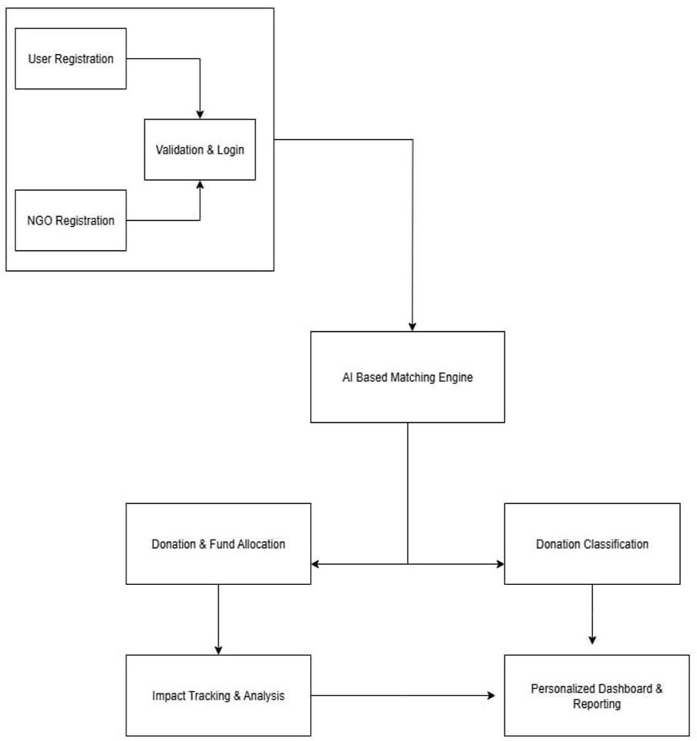

- Frontend: React (dynamic and responsive user interface)
- Backend: Node.js with Express (API handling and business logic)
- Database: MongoDB (NoSQL storage for users, donations, campaigns)

    - Software Environment

Category | Specification
Operating System | Windows / Linux / macOS
Frontend | React, HTML, CSS,  JavaScript
Backend | Node.js, Express
Database | MongoDB
Tools | VS Code, Postman
Browser | Chrome / Brave / Edge

  - Product Functions
- User Registration and Authentication
  - Register/login as donor, NGO, or admin.
  - Email-based verification and authentication.

Donation Management
  - Browse verified charity campaigns.
  - Make secure online donations (money or materials).
  - Track donations in real time.

Admin Dashboard
  - Verify NGOs and campaigns.
  - Monitor fraudulent activities.
  - Generate transparency and performance reports.

Analytics & Reports
  - Donor contribution summary.
  - NGO impact metrics.

- Specific Requirements
  - External Interfaces
- User Interface
  - Web-based responsive UI (React).
  - Donor dashboard: Donation history, impact reports.
  - NGO dashboard: Campaign creation, proof uploads.
  - Admin panel: Verification, monitoring, analytics.
- Input Interfaces
  - Registration details, campaign information, donation data, and feedback.
- Output Interfaces
  - Transparent transaction reports, NGO verification status, downloadable summaries.
- Database Interface
  - MongoDB stores users, donations, NGOs, campaigns, and proof documents.
  - Data retrieval optimized via Mongoose ORM.

  - Functional Requirements

Function | Description
User Registration | Users sign up and log in using verified credentials.
Campaign Management | NGOs create and manage donation campaigns.
Donation Processing | Donors make secure payments.
Transaction Tracking | Real-time monitoring of donation flow.
Report Generation | System generates donation and impact reports.

Performance Requirements
- System supports up to 100 concurrent users.
- Response time: < 3 seconds per request.
- Database can handle up to 50,000 records.

  - Design Constraints
- Developed using React, Node.js, Express, and MongoDB.
- Data encryption and HTTPS protocols required.
- Modular architecture for scalability and maintainability.

Software System Attributes Reliability:
System uptime ≥ 95%, with backup mechanisms.

Availability:
Accessible 24×7 via web browser.

Security:
- Secure login (bcrypt encryption).
- Encrypted transactions and data.

Maintainability:
- Modular codebase with proper documentation.
- APIs designed for easy integration.

Portability:
- Runs on multiple platforms (Windows, macOS, Linux).

- Software Design Document
Class Diagram:
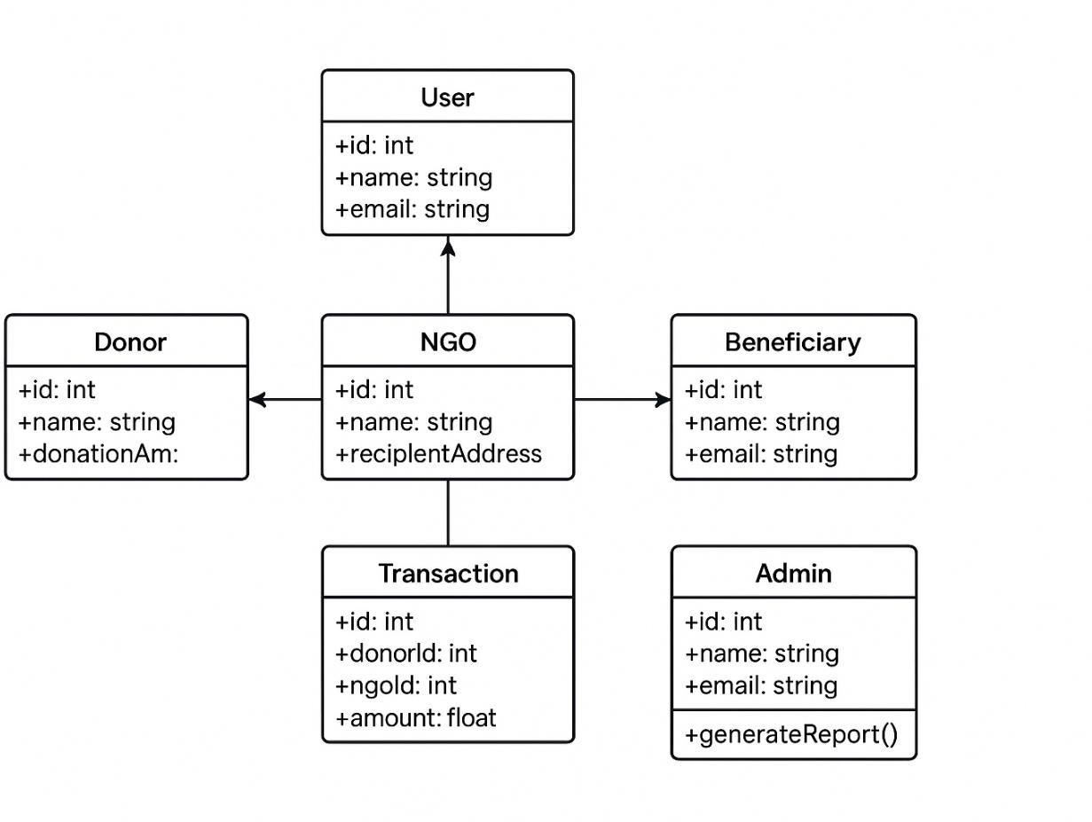

Data Flow Diagram:
Level 0:

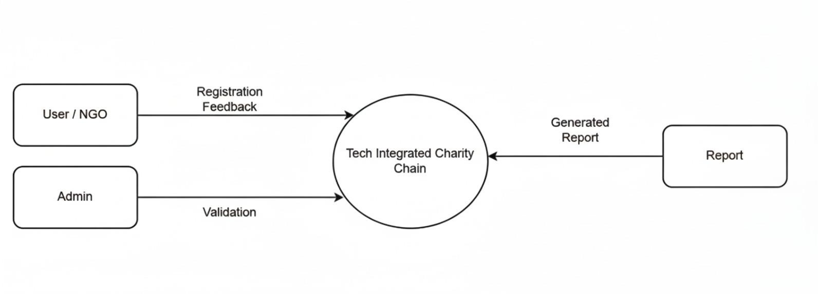

Level 1:

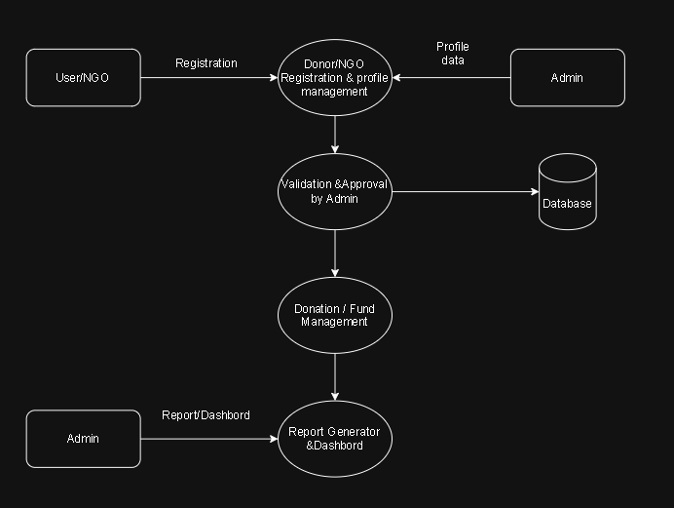

Level 2:

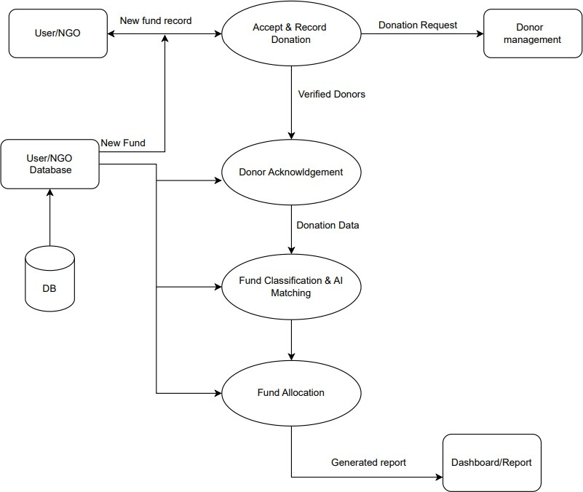

Behavioural Design

- Sequence Diagram

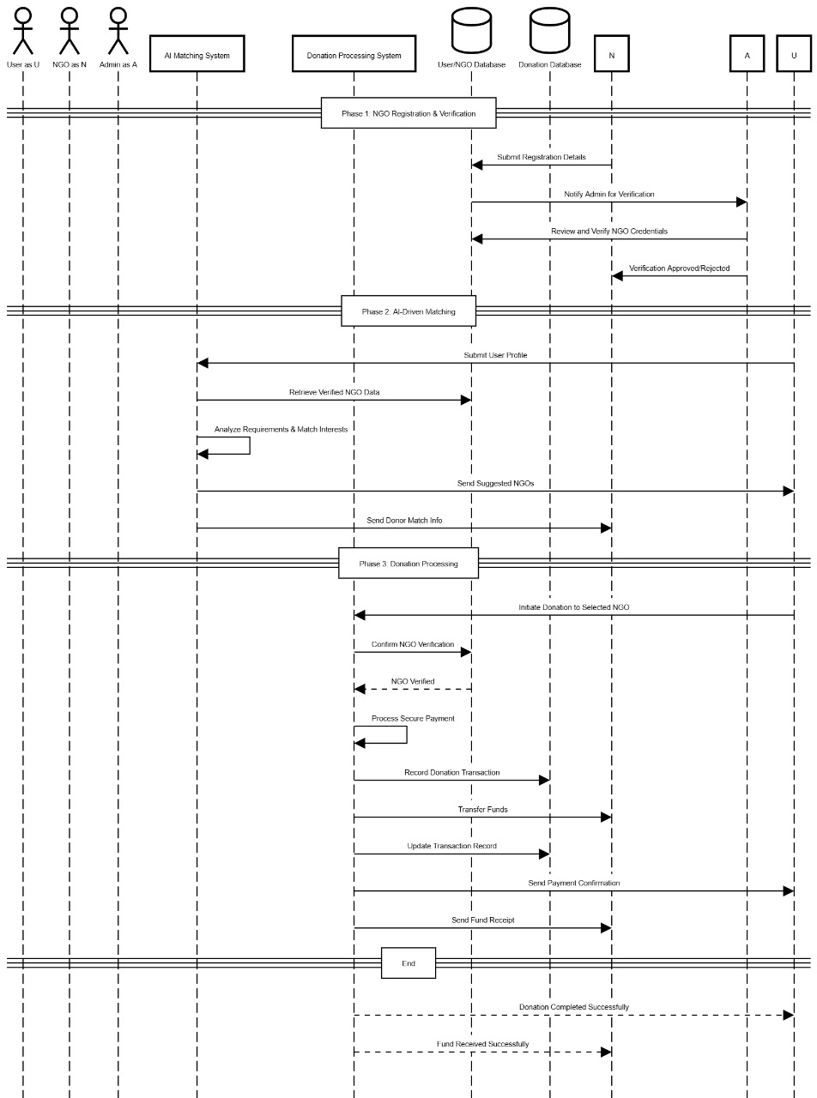

b)Collaboration Diagram

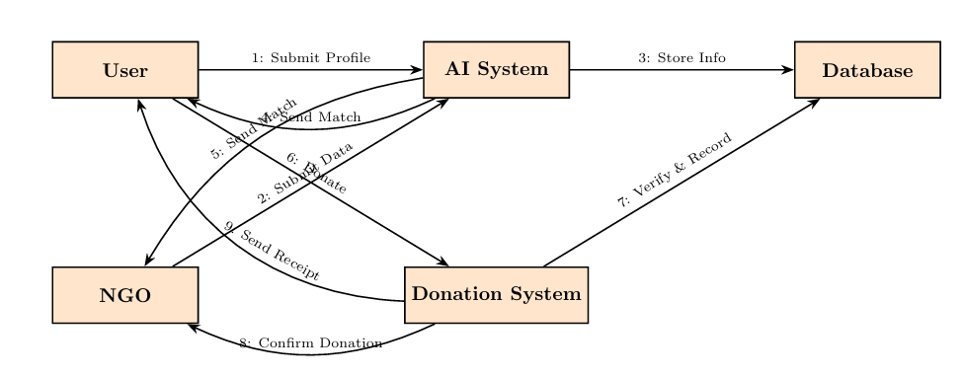

- Activity Diagram

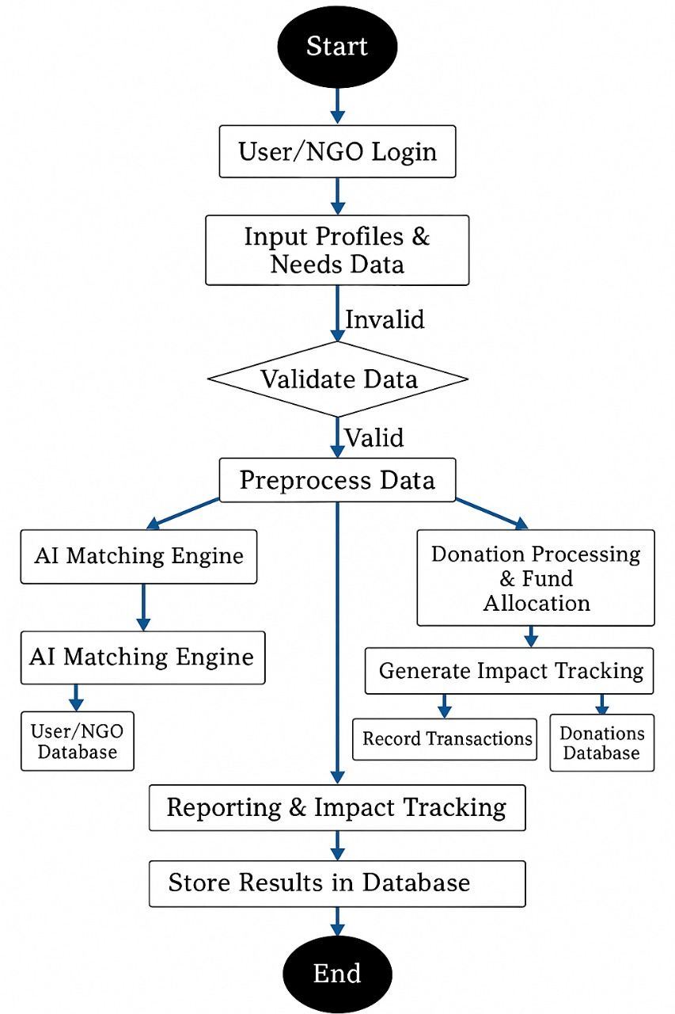

d)Component Diagram

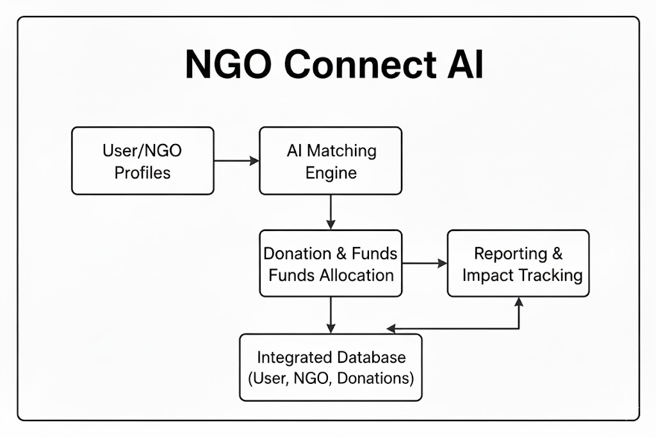
- Deployemnt Diagram

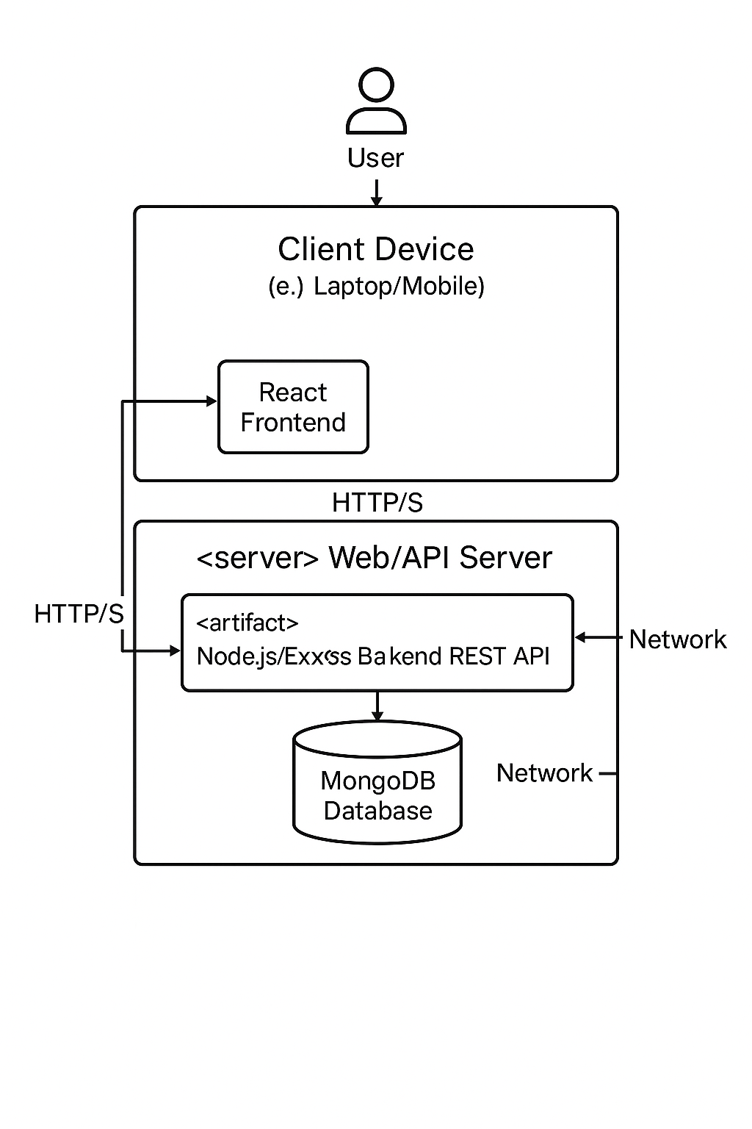

5.Screenshots
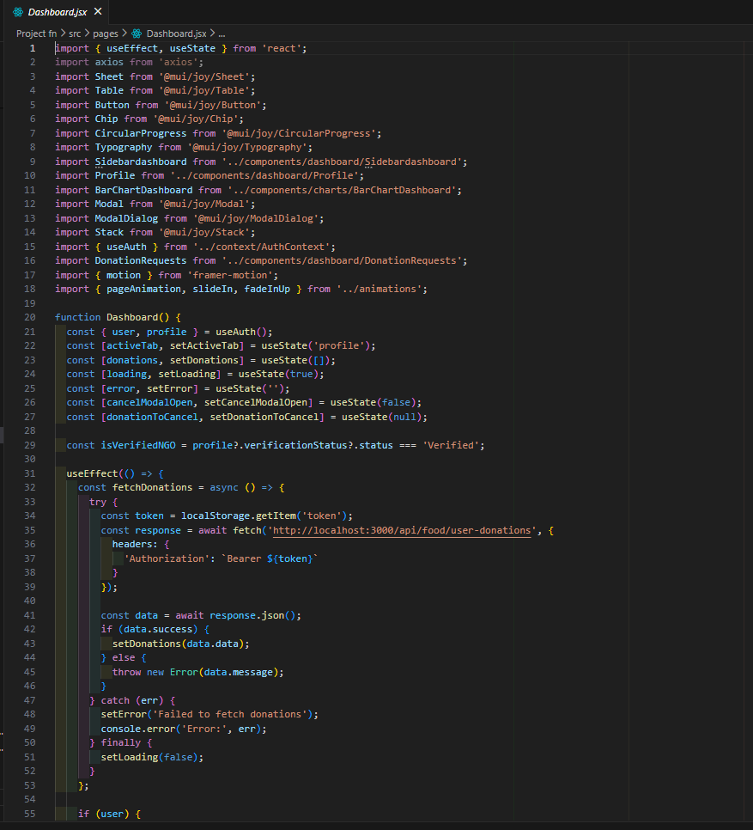

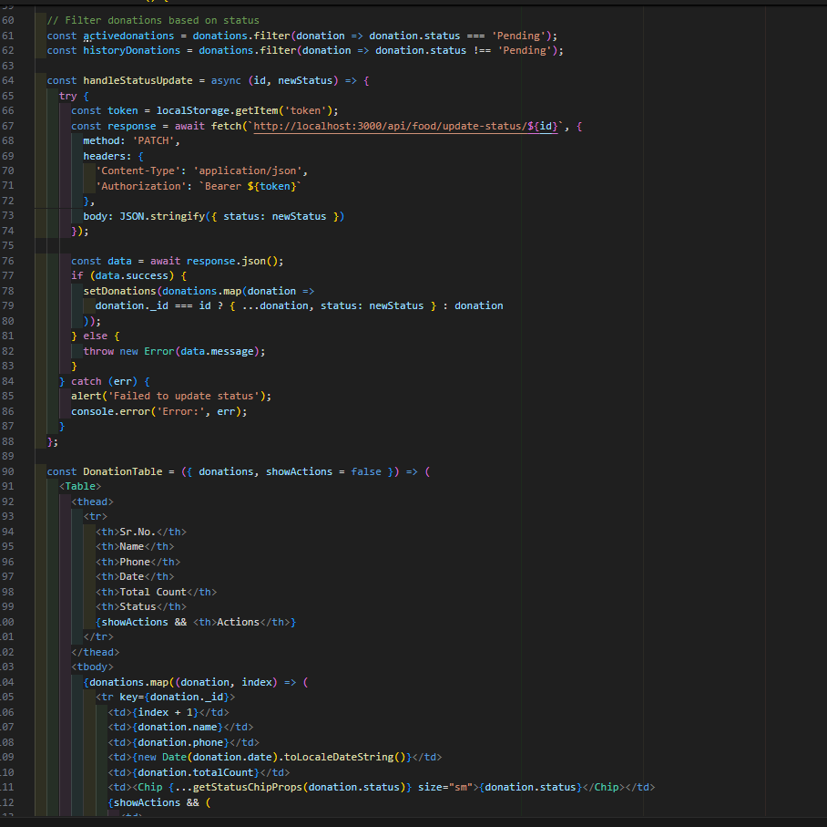

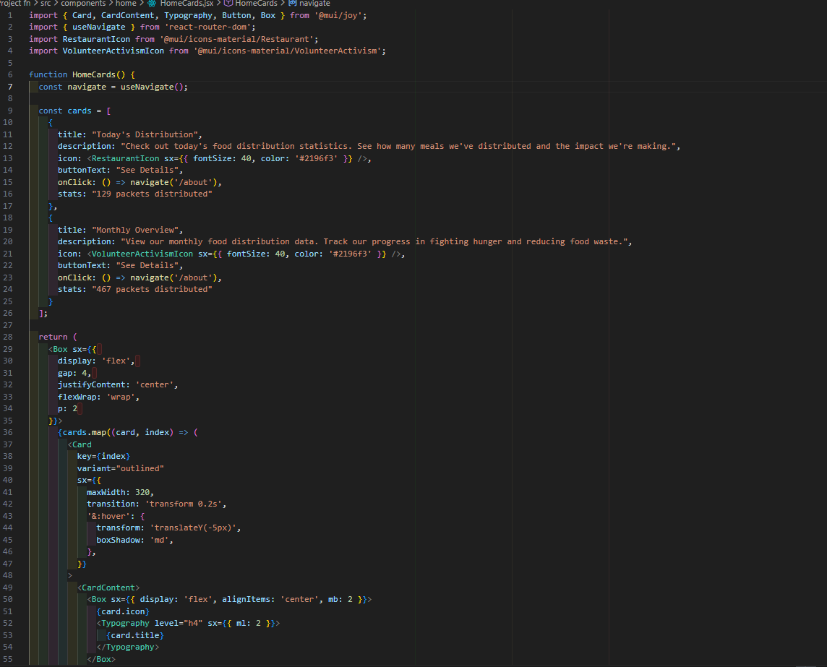
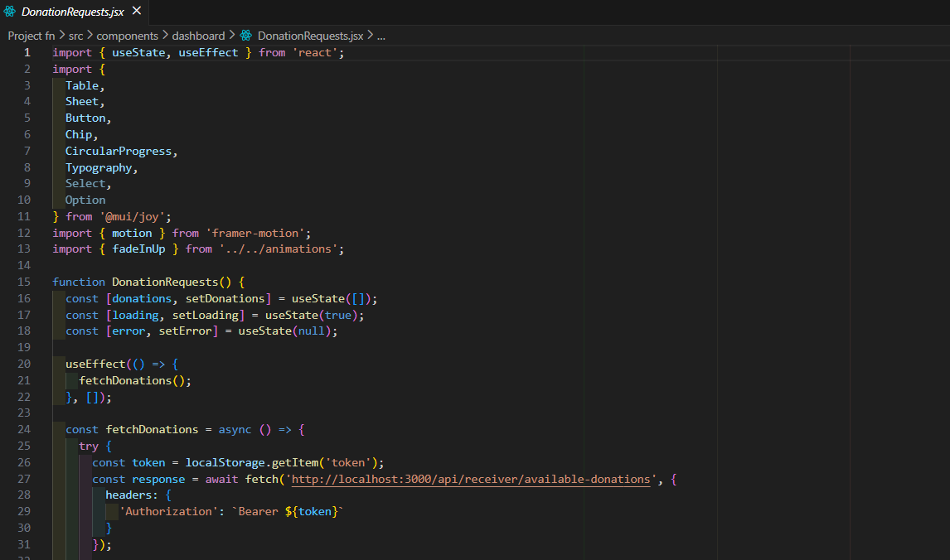

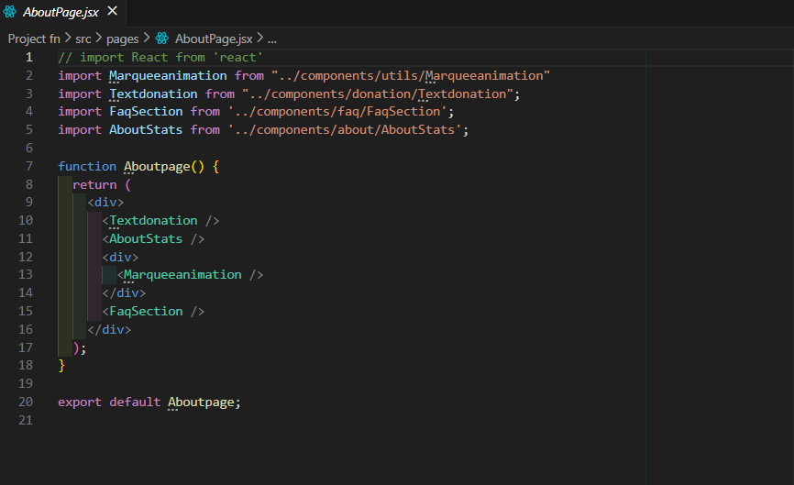

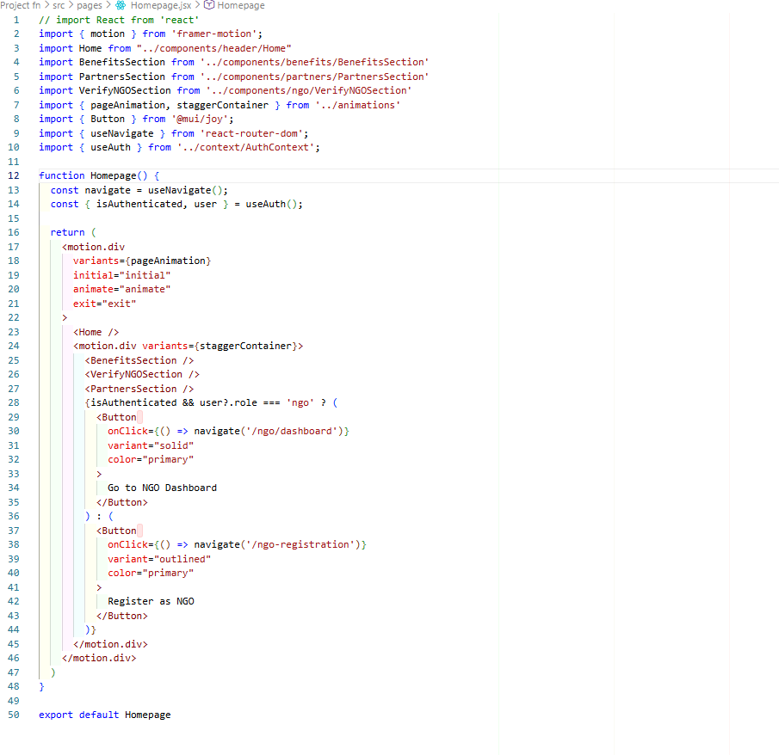

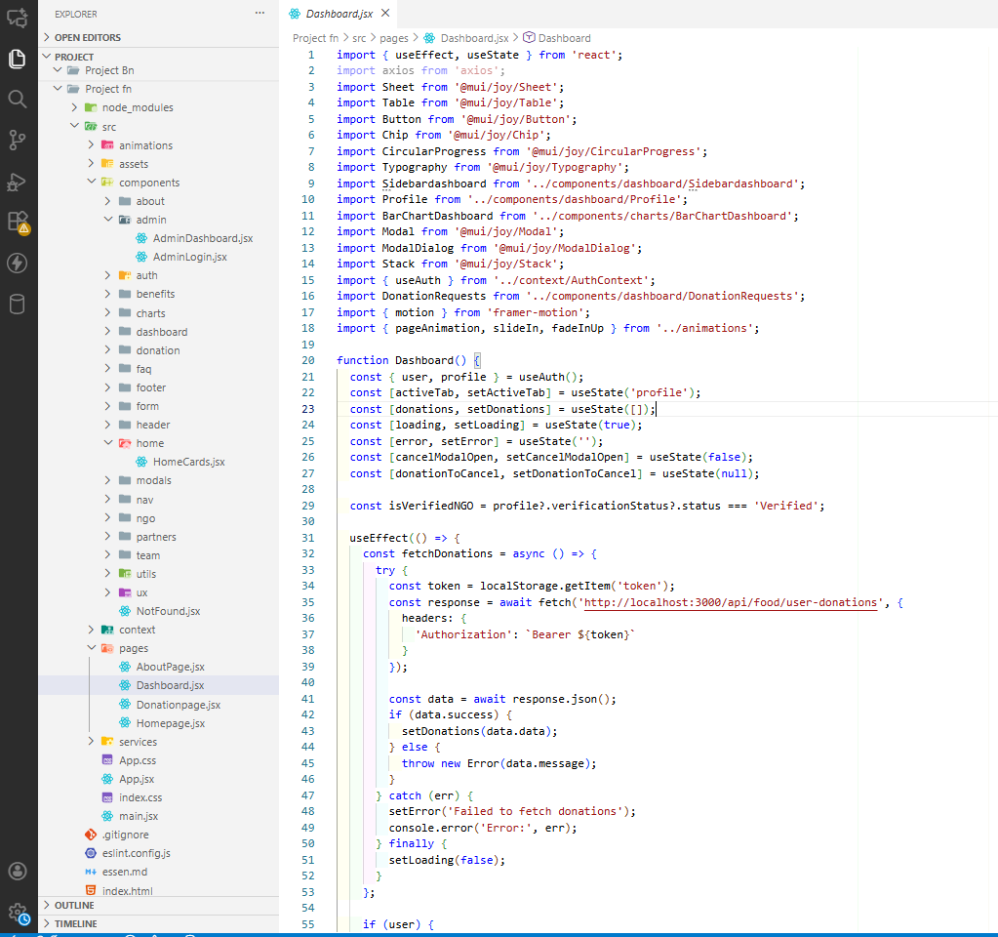

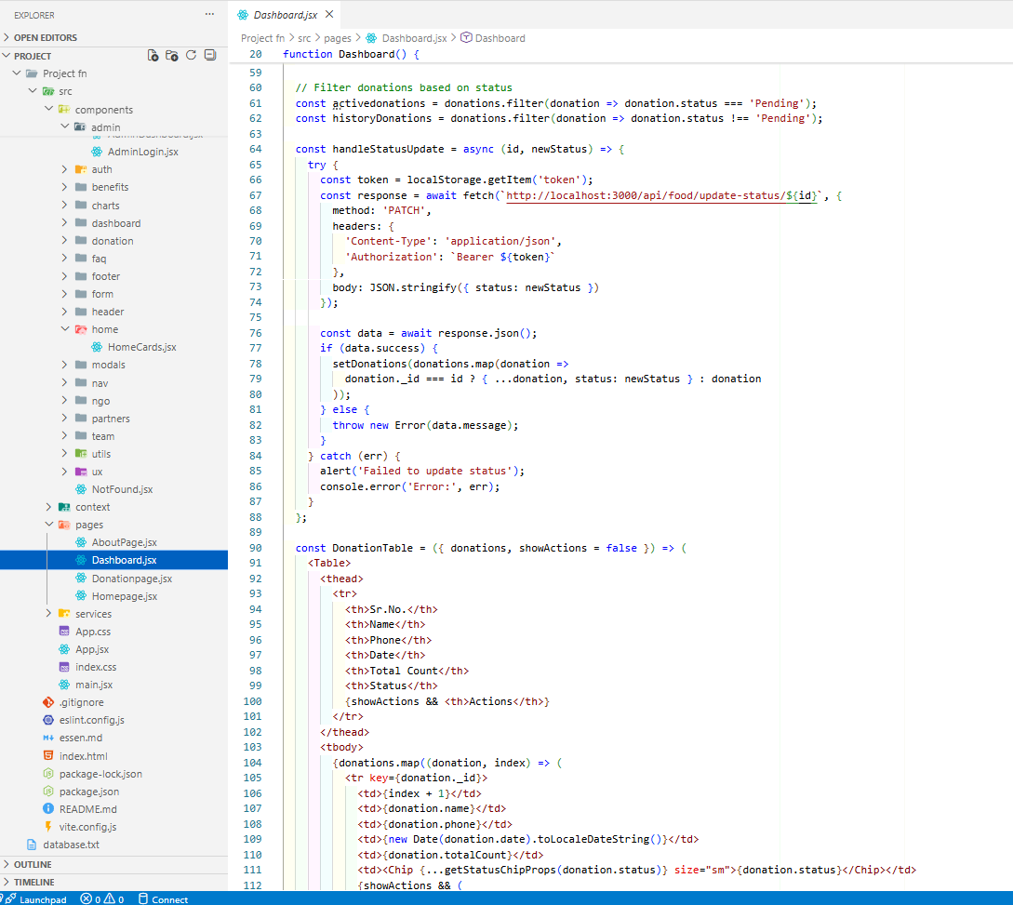

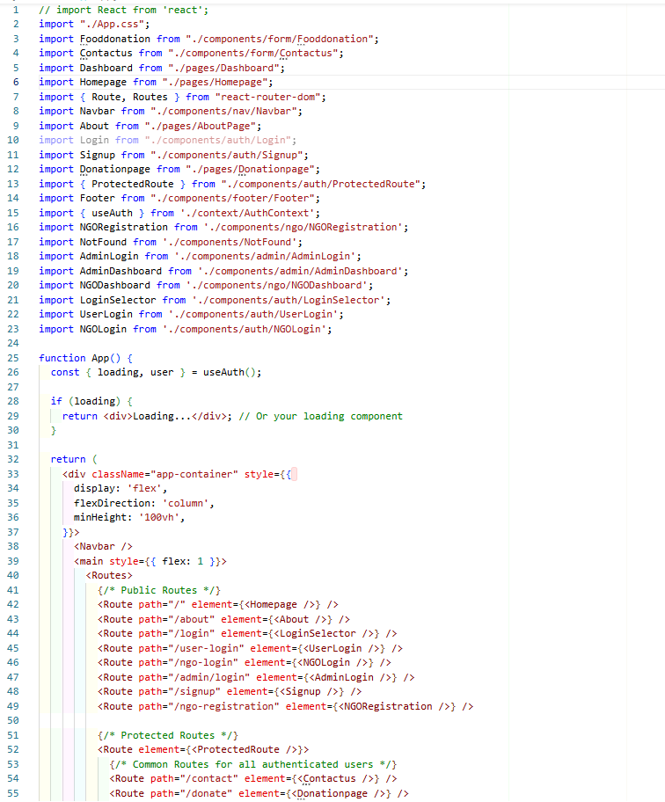

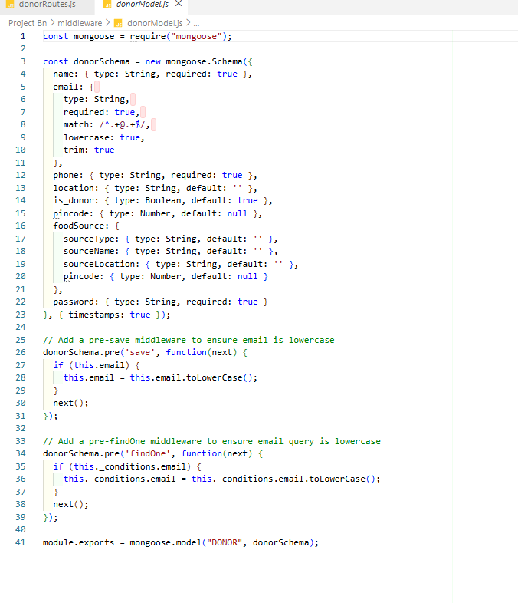

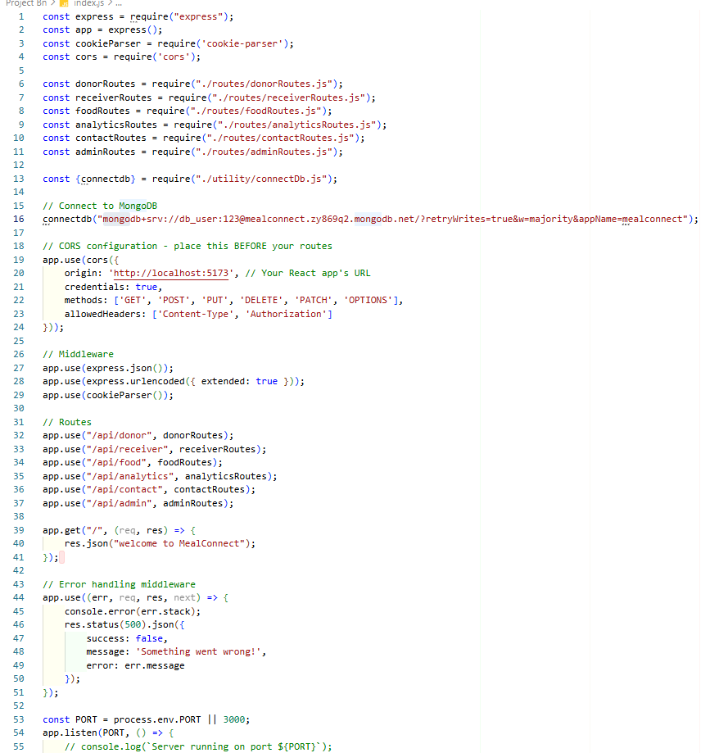
- References
- 1. Kumar, A., & Patel, R. (2022). AI-driven Recommendation in Charity Platforms.
- Journal of AI Research UNICEF Digital Reports. (2021). Transparency and Accountability in NGO Operations. United Nations
- Russell, S., & Norvig, P. (2021). Artificial Intelligence: A Modern Approach (4th Edition). Pearson.
- Kumar, S., & Kidwai, A. (2018). CSR disclosures and transparency among top Indian companies. International Journal of Indian Culture and Business Management, 16(1), 57 70.
- Podile, P. V., Reddy, K. P., Reddy, V. N. S., Babu, M. S., & Phani,
  - K. (2024). Artificial Intelligence and Corporate Social Responsibility: Synergies, Challenges and Future Directions. KL Business School.

